Modifying the regedit screen to add fonts to your computer

Note: You will need to do this when you are getting font issues in Advantzware when printing reports to the screen.

Start – Run
Type: Regedit

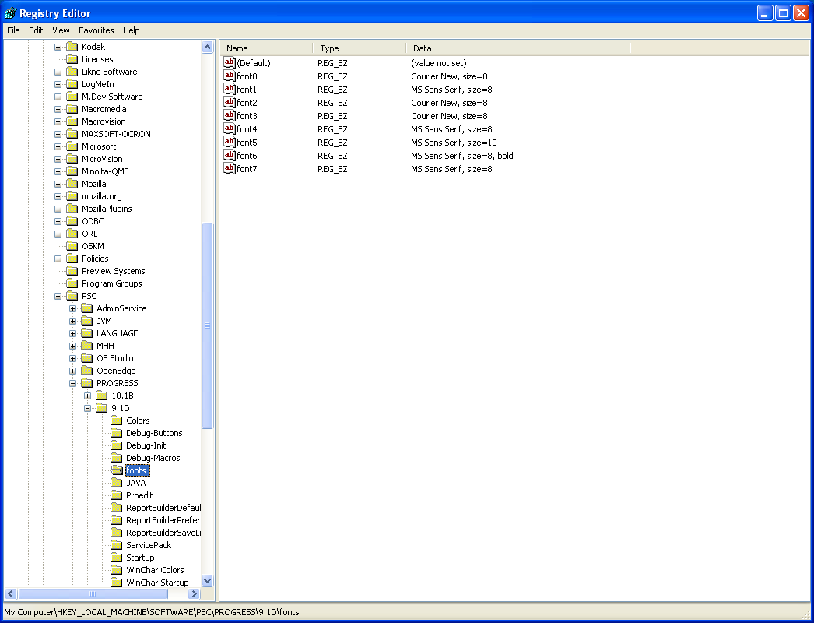

Right Click New then String Value
Right Click on font then go to modify. Place value data in field

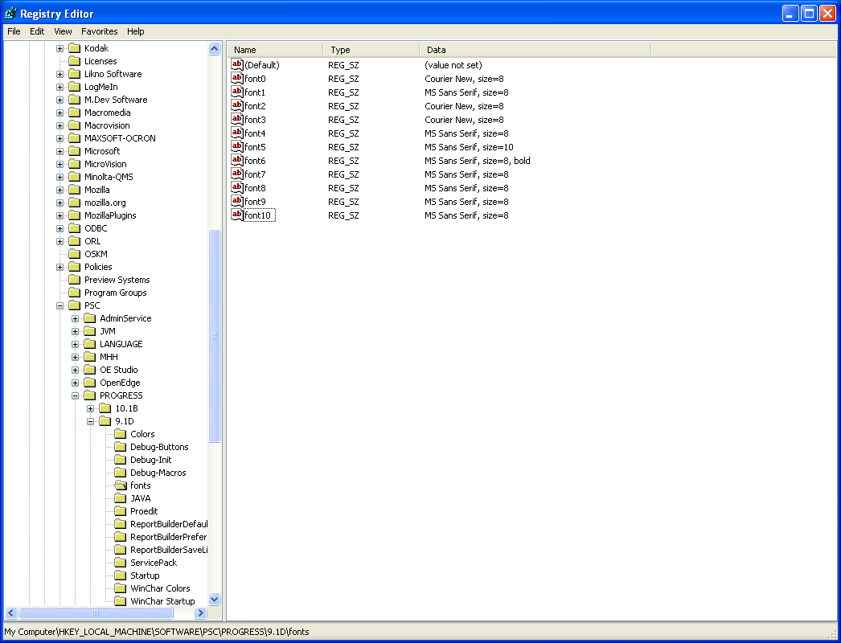

Sample screen when finished modifying fonts.

